Lab Assignment: Lab 5: Moment of Inertia

Title Author: Misbah Ahmed Nauman

CCID: misbahah

Student ID: 1830574

Lab Partner(s): Zeeshan

EN PH 131, ET23

TA: Kiril Kolevski

Date of Lab: 03/19/2024

Introduction:
Objectives:
In this lab, the primary objective is to determine the moment of inertia of a rotating bicycle wheel. This involves investigating the relationship between torque, Tao, and angular acceleration, alpha, which is like the relationship between force and linear acceleration in linear motion. We can calculate the moment of inertia of the wheel by suspending a mass from the wheel and measuring the resulting angular acceleration. Additionally, we aim to explore how well our experimental results align with theoretical predictions based on the mass and radius of the wheel.
Background Theory ^{[1]}:
Moment of inertia is a crucial concept in understanding the rotational motion of objects. Like mass in linear motion, moment of inertia, 𝐼, represents an object's resistance to changes in its rotational motion. For a rigid body rotating about a fixed axis, the rotational analog of Newton's second law is expressed as 𝜏 = 𝐼𝛼, where 𝜏 is the net torque applied to the object and 𝛼 is its angular acceleration.
In this experiment, we are looking at a bicycle wheel that rotates due to the suspension of mass on a thin cord that is wound around a cylindrical hub affixed to the wheel. The moment of inertia of a solid cylinder, such as the wheel, can be calculated theoretically using Eq. 5.4.
To determine the moment of inertia experimentally, we will use the setup mentioned above. By measuring the linear acceleration of the mass and the corresponding torque applied to the wheel, we can calculate the moment of inertia using Eq. 5.2. Through this experiment, we aim to gain a better understanding of moment of inertia and its relationship with torque and angular acceleration.
Equations ^{[1]}:
The equation
$α=\frac{a}{r}$ Eq. 5.1
can be used to calculate angular acceleration (denoted by 𝛼) of the wheel, where a represents the linear acceleration, and r represents the radius of the cylindrical hub.
To determine the moment of inertia, 𝐼, and the frictional torque, $τ_{f}$, of the bicycle wheel, we can use the linearized equation
$r⋅m⋅\left(g-a\right)=I⋅α+τ_{f}$ Eq. 5.2
where m represents the mass suspended, and g is the acceleration of free-fall.
Force of friction, $F_{f}$, on the axle can be calculated using the equation
$F_{f}=\frac{τ_{f}}{r_{f}}$ Eq. 5.3
where $r_{f}$ is the radius of the axle.
The moment of inertia, 𝐼, of the bicycle wheel about the axle can be theoretically approximated using the equation
$I=M⋅R^{2}$ Eq. 5.4
where M is the mass of the wheel, and R is the radius measured from the center of the hub to the middle of the tire.
Methods:
List of equipment’s used and description of setup:
- A bicycle wheel affixed to a hub that is rotated as the mass falls.
- A smart pulley sensor that detects signals from the experiment site and sends them to the connected computer.
- Mass pan and known masses are used to suspend mass that help rotate the wheel.
- LoggerPro software is used to compute data received from the smart pulley sensor and display data.
- A laptop is used to connect to the smart pulley sensor and provide access to the LoggerPro software.
- A meter stick is used to measure the diameter of the cylindrical hub.
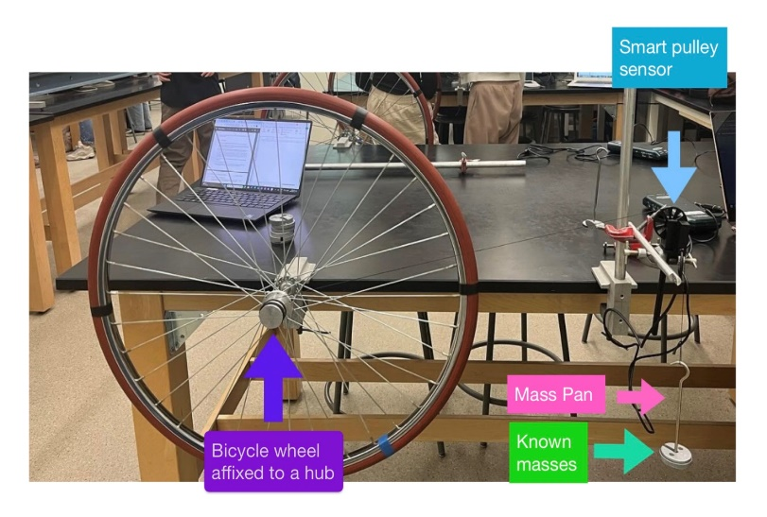

Fig. 5.1: A labelled picture of the experimental setup used for the experiment. The bicycle wheel is rotated when mass is added to the mass pan. The smart pulley sensor detects and sends signals to the LoggerPro software on the computer connected to the sensor.
Procedure ^{[1]}:
- The system is set up as shown in Fig. 5.1 starting with a total mass of 200 g (including the scale pan mass). The height of the smart pulley is adjusted so that the masses can fall about 1 m.
- Stabilize the mass and release it. Collect data as soon as the mass is released using the LoggerPro software and stop the data collection just before it hits the floor (to avoid ambiguous data).
- Using the software, plot out a velocity against time graph and use the built-in tools to measure the acceleration and its uncertainty. Record the data points into an excel sheet to collect data points for the graph in Fig. 5.2.
- Repeat the measurement for this mas. This would allow acceleration for each mass to be recorded twice for more accurate results.
- Repeat steps 1-4 again by incrementing the mass each time by 50 g until the final total mass is 600 g.
- Measure the radius, R, of the wheel using a meter rule, and measure the diameter of the cylindrical hub to calculate its radius, r.
Results:
Raw data:
Acceleration of free-fall, g = (9.81 $±$ 0.01) m/s²
Radius of cylindrical hub affixed to the wheel, r = (0.019 $±$ 0.005) m
Mass of wheel, M = (2.0 $±$ 0.2) kg
Diameter of the axle, $ⅆ_{f}$ = (7.78 $±$ 0.02) $×$ 10⁻³ m
Radius of the axle, $r_{f}$ = (3.89 $±$ 0.01) $×$ 10⁻³ m
Distance measured from the center of the hub to the middle of the tire, R = (0.285 $±$ 0.005) m
Table. 5.1: A sample data table for the Mass (in kg) suspended by the thread, linear acceleration, a (in m/s²) of the mass, angular acceleration, $α$ (in s⁻²) of the mass, and y-value that represents $r⋅m⋅\left(g-a\right)$ (in 𝑚²⋅𝑘𝑔⋅𝑠⁻²) of the system. All the masses were known in advance. Linear acceleration was computed using the LoggerPro software. Angular acceleration was calculated using Eq. 5.1. The Y-value was calculated using the raw data. The “angular acceleration, $α$ (in s⁻²)” column contains data points plotted on the x-axis of Fig. 5.2 and the “$r⋅m⋅\left(g-a\right)$ (in 𝑚²⋅𝑘𝑔⋅𝑠⁻²)” column contains the data points plotted on the y-axis of Fig. 5.2. There are two entries for each mass for more accurate results. The full table can be found in the Appendix.
mass (in kg) | linear acceleration, a (in m/s²) | angular acceleration, $α$ (in s⁻²) | $r⋅m⋅\left(g-a\right)$ (in 𝑚²⋅𝑘𝑔⋅𝑠⁻²)
0.200 | 0.00328 | 0.173 | 0.037
0.200 | 0.00344 | 0.181 | 0.037
0.250 | 0.00391 | 0.206 | 0.047
0.250 | 0.00421 | 0.221 | 0.047

Graphs:

Fig. 5.2: A plot of y-value (in 𝑚²⋅𝑘𝑔⋅𝑠⁻²) on the y-axis against angular acceleration, α (in s⁻²) on the x-axis is shown. A trendline of the best fit is also displayed with the equation y = 0.203x - 0.0013. Using the LINEST function in MS Excel gives us the slope = (0.203 $±$ 0.002) 𝑚²⋅𝑘𝑔 and the y-intercept = (0.0013 $±$ 0.0007) 𝑚²⋅𝑘𝑔⋅𝑠⁻².
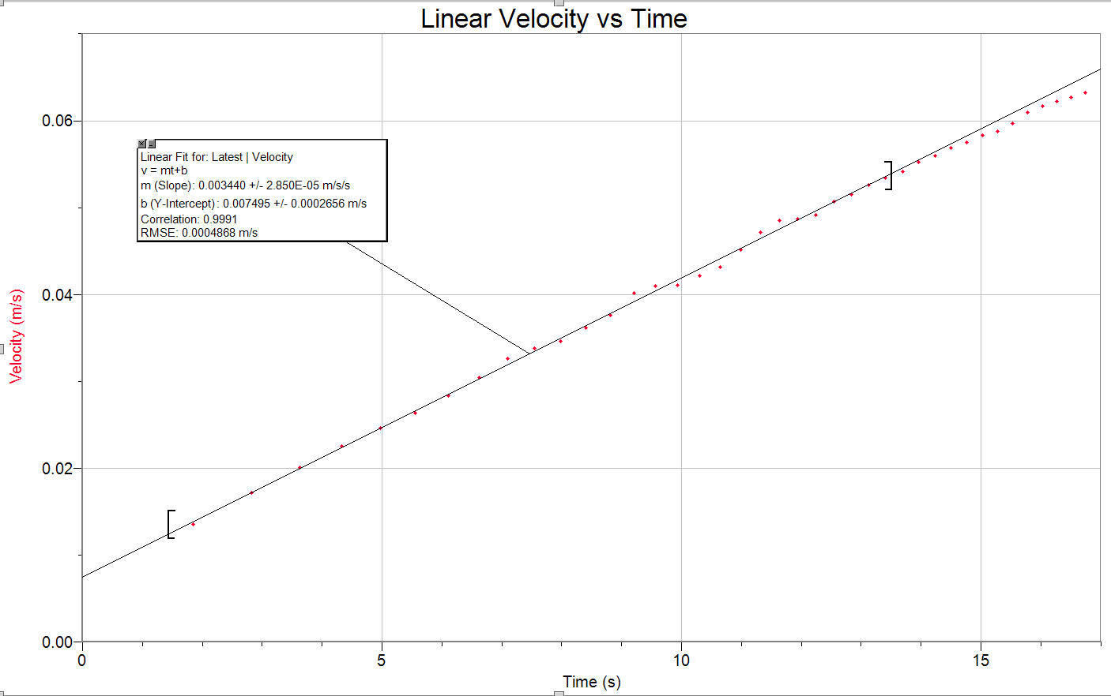
Fig. 5.3: A screenshot from one of the trials of the analysis for the mass falling in the Moment of Inertia experiment. LoggerPro software was used to detect signals from the smart pulley sensor and display a velocity against time chart. A built-in tool was used to calculate and display the acceleration along with its uncertainty on the graph.
Sample Calculations:
For Row 1 of Table 5.1:
$$α=\frac{a}{r}=\frac{0.00328}{0.019}=0.173 Δα=\sqrt{{\left(\frac{∂α}{∂a}Δa\right)}^{2}+{\left(\frac{∂α}{∂r}Δr\right)}^{2}}=0.05$$
Hence, Angular acceleration, $α$ = (1.7 $±$ 0.5) $×$10⁻¹ s⁻².
Y-value = $r⋅m⋅\left(g-a\right)$ = $0.019⋅0.200⋅\left(9.81-0.00328\right)$ = 0.0373
$ΔY-value$ = $\sqrt{{\left(\frac{∂y}{∂r}Δr\right)}^{2}{+\left(\frac{∂y}{∂m}Δm\right)}^{2}{\left(\frac{∂y}{∂g}Δg\right)}^{2}{\left(\frac{∂y}{∂a}Δa\right)}^{2}}$= 0.01
Hence, Y-value = (4 $±$ 1) $×$10⁻² 𝑚²⋅𝑘𝑔⋅𝑠⁻².
$I=M⋅R^{2}$ = (2.0) $⋅{(0.285)}^{2}$ = 0.162$ΔI=\sqrt{{\left(\frac{∂I}{∂M}∂M\right)}^{2}{\left(\frac{∂I}{∂R}∂R\right)}^{2}}$ = 0.02
Hence, Theoretical moment of inertia, $I=$ (1.6 $±$ 0.2) $×$10⁻¹ 𝑚²⋅𝑘𝑔
From Fig. 5.2, we know that $τ_{f}$ = (0.03 $±$ 0.01) 𝑚²⋅𝑘𝑔⋅𝑠⁻²
$F_{f}=\frac{τ_{f}}{r_{f}}$ = $\frac{0.03}{0.00389}$ = 7.71
Hence, Force of friction, $F_{f}$ = 7.71 N.
Analysis:
From Fig. 5.2, we know that slope = $I=$ (0.203 $±$ 0.002) 𝑚²⋅𝑘𝑔 and that theoretical moment of inertia, $I=$ (1.6 $±$ 0.2) $×$10⁻¹ 𝑚²⋅𝑘𝑔. The effective torque (or y-value of Fig. 5.2) was found to be (4 $±$ 1) $×$10⁻² 𝑚²⋅𝑘𝑔⋅𝑠⁻². Using this, we found the force of friction, $F_{f}$ = 7.71 N.
Discussion:
Experimental value for moment of inertia, $I=$ (0.203 $±$ 0.002) 𝑚²⋅𝑘𝑔.
Theoretical value for moment of inertia, $I=$ (1.6 $±$ 0.2) $×$10⁻¹ 𝑚²⋅𝑘𝑔.
Since both values are within 2 error intervals, they are in modest agreement.
Force of friction was found to be $F_{f}$ = 7.71 N.
The line of best fit in Fig. 5.2 seems to match up nicely with our data, and there don't appear to be any strange outliers. Our experimental value for the moment of inertia is close to the theoretical one, only off by about two error intervals. However, our measurement of the wheel's radius could have been more accurate. Using just a meter stick and our eyes might not have been the most precise method, we likely had parallax error while measuring the radius.
We could have also been a bit more careful with how we dropped the weight. Perhaps dropping it from a higher point, like 100 cm instead of around 80 cm, could have given us more accurate readings. Additionally, waiting a bit longer for the weight to come to a complete stop before stopping to record the data might have helped with more data points, leading to a more accurate result.
While collecting the data for the experiment, we had a few anomalous points that we chose to proceed with. That may have led to significant errors in our results. We also let the mass fall less than 80 cm each time, which may have interfered with our results.
Conclusion:
Throughout this experiment, we investigated the moment of inertia of a rotating bicycle wheel. Our main objective was to understand how torque and angular acceleration relate to each other and how they affect the rotational motion of objects. By suspending masses from the wheel and measuring the resulting angular acceleration, we aimed to determine the moment of inertia experimentally. Additionally, we compared our experimental results with theoretical predictions based on the mass and radius of the wheel.
To conduct the experiment, we set up a system involving a bicycle wheel affixed to a hub, a smart pulley sensor connected to a computer running LoggerPro software, and known masses used to suspend from the wheel. We adjusted the height of the smart pulley to ensure the masses fell about 1 meter. Data collection involved releasing the mass, recording data using LoggerPro, and plotting velocity against time graphs to measure acceleration.
However, our experimental setup and data collection methods had some limitations. The measurement of the wheel's radius using a meter stick may not have been entirely accurate, especially considering the wear and tear on the wheel. Dropping the masses from a higher height and waiting longer for the masses to come to a complete stop could have potentially improved the accuracy of our results.

In conclusion, our experimental results for the moment of inertia of the bicycle wheel were in modest agreement with theoretical predictions. The slope obtained from our data analysis was (0.203 $±$ 0.002) 𝑚²⋅𝑘𝑔, while the theoretical moment of inertia was determined to be (1.6 $±$ 0.2) $×$10⁻¹ 𝑚²⋅𝑘𝑔. Since both values were within two error intervals, they were in modest agreement.
Our experiment provided valuable insights into the rotational motion of objects and the concept of moment of inertia. Despite some limitations in our experimental setup and data collection methods, we were able to achieve results that were consistent with theoretical expectations. Moving forward, improvements in measurement techniques and experimental procedures could further enhance the accuracy and reliability of similar experiments.

References:
[1] Lab Manual EN PH 131. Edmonton: University of Alberta, Department of Physics.
Acknowledgements:
I would like to express my gratitude to my lab partner, Zeeshan, for his invaluable assistance in helping perform the experiment by adding different weights to the mass pan and helping record the data on his computer. Additionally, I extend my appreciation to our lab Teaching Assistant, Mr. Kiril Kolevski, for providing consistent guidance and support throughout the entire laboratory experiment.

Appendix:
A.1: A sample data table for the Mass (in kg) suspended by the thread, linear acceleration, a (in m/s²) of the mass, angular acceleration, $α$ (in s⁻²) of the mass, and y-value that represents $r⋅m⋅\left(g-a\right)$ (in 𝑚²⋅𝑘𝑔⋅𝑠⁻²) of the system. All the masses were known in advance. Linear acceleration was computed using the LoggerPro software. Angular acceleration was calculated using Eq. 5.1. The Y-value was calculated using the raw data. The “angular acceleration, $α$ (in s⁻²)” column contains data points plotted on the x-axis of Fig. 5.2 and the “$r⋅m⋅\left(g-a\right)$ (in 𝑚²⋅𝑘𝑔⋅𝑠⁻²)” column contains the data points plotted on the y-axis of Fig. 5.2. There are two entries for each mass for more accurate results.
mass (in kg) | linear acceleration, a (in m/s²) | angular acceleration, $α$ (in s⁻²) | $r⋅m⋅\left(g-a\right)$ (in 𝑚²⋅𝑘𝑔⋅𝑠⁻²)
0.200 | 0.00328 | 0.173 | 0.037
0.200 | 0.00344 | 0.181 | 0.037
0.250 | 0.00391 | 0.206 | 0.047
0.250 | 0.00421 | 0.221 | 0.047
0.300 | 0.00505 | 0.266 | 0.056
0.300 | 0.00496 | 0.261 | 0.056
0.350 | 0.00584 | 0.307 | 0.065
0.350 | 0.00584 | 0.307 | 0.065
0.400 | 0.00668 | 0.351 | 0.075
0.400 | 0.00664 | 0.350 | 0.075
0.450 | 0.00747 | 0.393 | 0.084
0.450 | 0.00754 | 0.397 | 0.084
0.500 | 0.00839 | 0.441 | 0.093
0.500 | 0.00838 | 0.441 | 0.093
0.550 | 0.00930 | 0.489 | 0.102
0.550 | 0.00929 | 0.489 | 0.102
0.600 | 0.0102 | 0.535 | 0.112
0.600 | 0.0101 | 0.532 | 0.112

